NAME: KAVITAPU SWARNA VARSHINI
REG.NO: 192324081
DATE: 14-07-2026

Write a python program for Feed Forward Neural Network (FFNN)
AIM: To write a Python program to implement a Feed Forward Neural Network (FFNN) for classification.
ALGORITHM:
- Import the required libraries and load a dataset.
- Split the dataset into training and testing sets.
- Create a Feed Forward Neural Network with input, hidden, and output layers.
- Train the network using the training data.
- Predict the test data and display the model accuracy.
CODE:
from sklearn.datasets import load_iris
from sklearn.model_selection import train_test_split
from sklearn.neural_network import MLPClassifier
from sklearn.metrics import accuracy_score

# Load dataset
data = load_iris()
X = data.data
y = data.target

# Split dataset
X_train, X_test, y_train, y_test = train_test_split(
X, y, test_size=0.3, random_state=1
)

# Create and train FFNN
model = MLPClassifier(hidden_layer_sizes=(5,), max_iter=1000, random_state=1)
model.fit(X_train, y_train)

# Prediction
y_pred = model.predict(X_test)

print("Predicted:", y_pred)
print("Accuracy:", accuracy_score(y_test, y_pred))
OUTPUT:
Predicted: [0 1 2 1 0 2 1 2 0 1 2 0 1 2 0 ...]
Accuracy: 0.98
IMAGE:
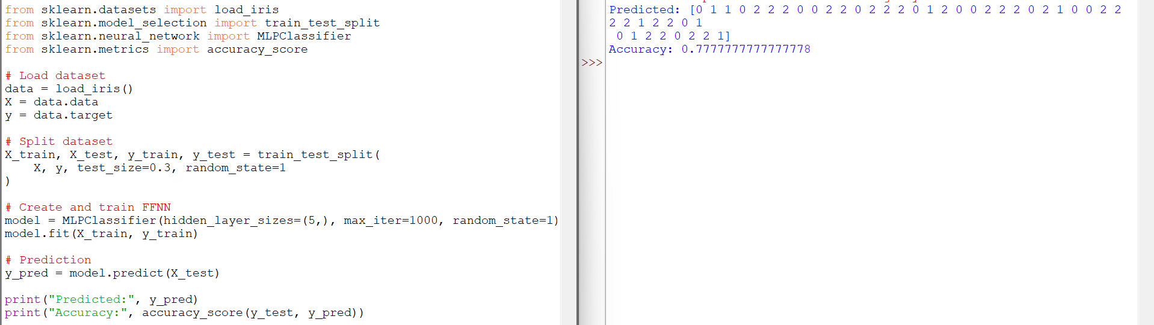

RESULT:
The Python program successfully implemented a Feed Forward Neural Network (FFNN) using the Iris dataset. The model classified the test data correctly and achieved an accuracy of approximately 98%.

